- International Automotive Workers Coordination -
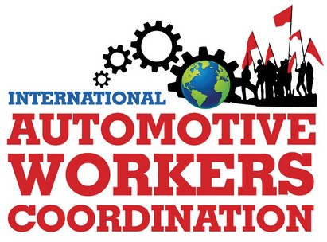
International Coordinating Group
Internationale Koordinierungsgruppe
Grupo Internacional de Coordinación
Grupo Internacional de Coordenação
Groupe de coordination internationale
Gruppo di coordinamento internazionale
Email: icog@iawc.info ; contact@iawc.info
Website: www.automotiveworkers.org
Donation Account: Erwin Dietrich
IBAN DE58 7001 0080 0349 3138 02 – BIC PBNKDEFFXXX
14 July 2024
Protest and solidarity resolution against the announced plans for a possible Audi plant closure in Brussels, Belgium

Dear colleagues,

The International Coordination Group of the International Automotive Workers' Coordination strongly protests against Audi's plans to close the plant in Brussels.
At least 3,000 jobs are directly affected and others at affiliated suppliers. The workforce has already had to accept production cuts and short-time working since the beginning of the year. 371 temporary workers have already been terminated. When production of the Q8-e-tron is relocated to Mexico, there will be no successor model. The workforce is facing the end.
The production costs in Brussels are too high, they say. It can't be the wages. They are only a fraction of turnover. For years, they have always been right when it came to taking over production capacities and models from other plants. Audi makes billions in profits, the Board of Management and shareholders pocket millions. In negotiations with the Belgian government, Audi is relying on state subsidies.
The workforce in Brussels is to be blackmailed into making concessions and played off against other plants. We say no to this!
The works councils at Audi in Germany and the employee representatives on the Audi Supervisory Board have protested against the planned closure and declared their solidarity with the workforce. However, hopes for new models with concessions or insight from the Board of Management and for co-management are misplaced here.
The workforce needs the broad international workers' solidarity behind them immediately if they take strike action to preserve the plant and fight for every job.
The workforces in the VW and Audi Group must not allow themselves to be blackmailed and played off against each other. A decisive struggle will also encourage other workforces to go on the offensive, for the takeover of the agency workers at VW and Audi, against the planned dismissal of the 1200 temporary workers at VW Zwickau.
Let us learn from the experience of the automotive workers' movement. At Opel in Bochum, the struggle of the workforce, above all the independent strike, delayed the closure of the plant for years. A rally and family celebration “Lessons from 20 years of struggle at Opel” will take place on October 5 in Bochum, Germany.
The International Automotive Workers' Coordination will actively participate. We would be delighted to welcome colleagues from Audi Brussels to Bochum. Sharing experiences, discussing the common struggle and celebrating belong together.

Let's strengthen international worker and trade union unity!
Long live international solidarity!

