- International Automotive Workers Coordination -
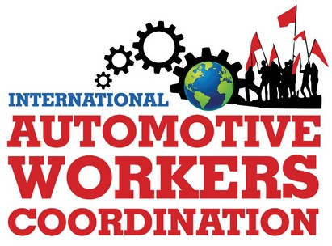
International Coordinating Group
Internationale Koordinierungsgruppe
Grupo Internacional de Coordinación
Grupo Internacional de Coordenação
Groupe de coordination internationale
Gruppo di coordinamento internazionale
Email: icog@iawc.info ; contact@iawc.info
Website: www.automotiveworkers.org
Donation Account: Erwin Dietrich
IBAN DE58 7001 0080 0349 3138 02 – BIC PBNKDEFFXXX
14 July 2024

ICOG statement against Israel's genocide in Gaza

SOLIDARITY WITH THE PALESTINIAN PEOPLE

For nine months, the fascist state of Israel has been committing genocide against the Palestinian people in Gaza and the entire region! It has indiscriminately attacked the population and killed more than 40,000 people, most of them women and children. We condemn the bloody attack by Hamas on October 7, 2023, but it does not legitimize the genocide now taking place in front of the whole world.
It has not succeeded in breaking the heroic resistance of the Palestinian people. Many demonstrations around the world show solidarity and demand support.
Despite the UN resolutions calling for a ceasefire, the various capitalist governments, with the US at the forefront, have directly supported the state of Israel, making themselves complicit.
Through the ICOG, auto workers are expressing their solidarity with the Palestinian people and their rejection of the genocide being perpetrated by Israel.
We call on workers around the world to continue and intensify mobilizations in solidarity with the Palestinian people.
Freedom for Palestine! Against all anti-Semitism!
Long live International Solidarity!

