- International Automotive Workers Coordination -
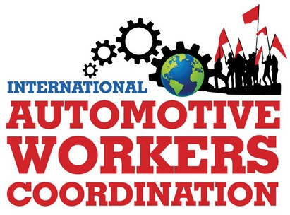
International Coordinating Group
Internationale Koordinierungsgruppe
Grupo Internacional de Coordinación
Grupo Internacional de Coordenação
Groupe de coordination internationale
Gruppo di coordinamento internazionale
Email: icog@iawc.info ; contact@iawc.info
Website: www.automotiveworkers.org
Donation Account: Erwin Dietrich
IBAN DE58 7001 0080 0349 3138 02 – BIC PBNKDEFFXXX
14 July 2024
Resolution against the increased danger of fascism worldwide

The International Coordinating Group takes an offensive against the vote gains and government takeovers of reactionary and fascist parties and coalitions. The results of the European elections in June 2024 show that an intensified fascist threat is emerging internationally. Ultranationalist and even openly fascist parties received an unprecedented increase in votes. Milei in Argentina and the neo-fascist Meloni in Italy succeeded in coming to power and immediately attacked workers' rights and cut social benefits. Modi in India remains in office. Netanyahu inhumanely bombs the Gaza Strip. Trump may even become president of the USA again. The imperialist competition and the course towards imperialist wars are linked to an openly anti-worker and anti-people policy. To this end, they spread slogans such as "Our country first!", promote inhuman racism, anti-communism, misogynistic policies and particularly aggressive policies against refugees. As deniers of the global climate catastrophe, they are rolling back environmental protection regulations worldwide. They want to continue burning fossil fuels and sticking to the internal combustion engine. However, this will exacerbate the global environmental catastrophe with disastrous consequences for people and nature.
In addition to yellow fascist trade unions in many countries, fascists such as the "Zentrum Automobil" group are pursuing a policy of division in companies such as Mercedes in Germany and are attacking workers' unity and democratic trade unions. Instead of international unity and transnational and company-wide struggles, they promote competition between the international monopolies.
Based on a demagogic appearance, they camouflage their inner fascist nature with terms of the workers' movement and spread lies and even conspiracy theories.
This does not make it easy for workers and their families to see through this and some become supporters and promoters of this nationalist ideology themselves. Many do not yet realize that they themselves are supporting anti-worker and anti-mass politics.
At the same time, millions of people in Germany and France are taking to the streets against the fascist of AfD (Alternative for Germany) or Le Pen’s Rassemblement National. The fighting in Argentina against the Milei government continues and the elections in France and the UK in recent weeks have shown that right-ward and fascist movements can be stopped by a proper left-wing alliance policy.
It is therefore necessary to carry out educational and awareness-raising work, especially among young people. For the International Automotive Workers' Coordination it is of great importance to strengthen internationalist consciousness, to unite colleagues and even entire workforces throughout the company against the international corporations and against subordination to profit interests.
In our International Program of Struggle, we already adopted the demands in February 2020:
“No inch for reactionary and fascist forces in the companies!
Ban all fascist organizations, parties and their propaganda!”
We are actively working to build a broad international anti-fascist front at various levels. The automotive workers and their families have a great responsibility to strengthen it.
Long live international solidarity!

